**Labcycle 4**

Experiment No: 6

AIM : Familiarisation of TCL Commands

1: Create a Table ‘Order_Details’ with the given data and perform the following operations

>>create table Order_Details ( Order_ID int, Product_Name varchar (50), Order_Num int, Order_Date date );

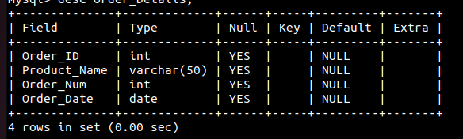

a) Start a new transaction and insert 2 rows into the table Order_Details.

>>start transaction;

>>insert into Order_Details values (1, 'Laptop', 5544, '2020-02-01');

>>insert into Order_Details values (2, 'Mouse', 3322, '2020-02-01');

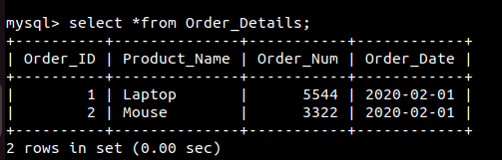

b) Display the details of Order_Details.

>>select *from Order_Details;



c) Rollback the current transaction and check the contents of the table Order_Details.

>>rollback;

>>select *from Order_Details;



d) Start a new transaction and delete 2 rows from the table Order_Details.

>>START TRANSACTION;

>>insert into Order_Details values (1, 'Laptop', 5544, '2020-02-01');

>>insert into Order_Details values (2, 'Mouse', 3322, '2020-02-01');

>>insert into Order_Details values (3, 'Desktop', 2135, '2020-01-05');

>>insert into Order_Details values (4, 'Mobile', 3432, '2020-02-22');

>>insert into Order_Details values (5, 'Anti-Virus', 5648, '2020-03-10');

>>DELETE FROM Order_Details WHERE Order_Num IN (5544, 3322);

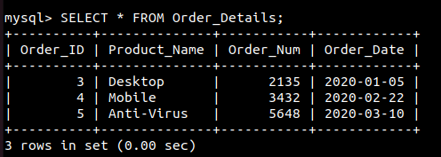

e) Display the details of Order_Details.

>>select *from Order_Details;



f) Commit the current transaction and check the details of the table Order_Details.

>>COMMIT;

>>SELECT * FROM Order_Details;

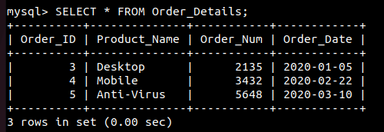

g)

g) Disable autocommit and create a savepoint named ‘Check_Updates’.

>>SET AUTOCOMMIT = 0;

>>SAVEPOINT Check_Updates;

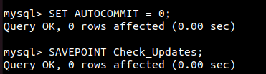

h) Update details of the order with Order_Num 5544.

>>insert into Order_Details values (1, 'Laptop', 5544, '2020-02-01');

>>UPDATE Order_Details SET Order_Date = '2020-03-12' WHERE Order_Num = 5544;

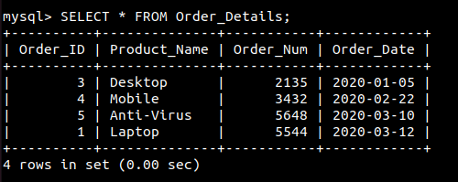

i) Insert 2 more rows into the table.

>>insert into Order_Details values (6, 'Keyboard', 5543, '2020-03-01');

>>insert into Order_Details values (7, 'Monitor', 5343, '2020-03-01');

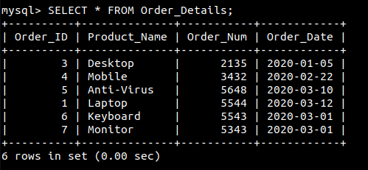

j) Create a savepoint named ‘Check_delete’

>>SAVEPOINT Check_delete;



k) Delete order details of a product named ‘Laptop’.

>>DELETE FROM Order_Details WHERE Product_Name = 'Laptop';

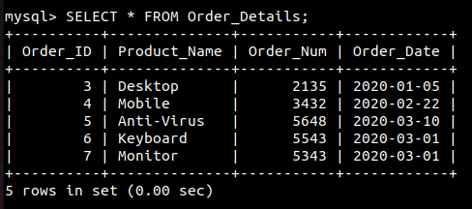

l) Display the current details of the table Order_Details.

>>SELECT * FROM Order_Details;



m) Rollback to savepoint ‘Check_delete’ and check the details of the table Order_Details.

>>ROLLBACK TO SAVEPOINT Check_delete;

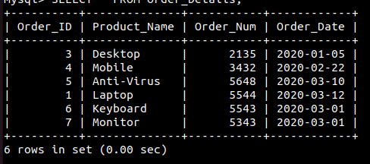>>SELECT * FROM Order_Details;

n) Rollback to savepoint ‘Check_Updates’ and check the details of the table Order_Details.

>>ROLLBACK TO SAVEPOINT Check_Updates;

>>SELECT * FROM Order_Details;

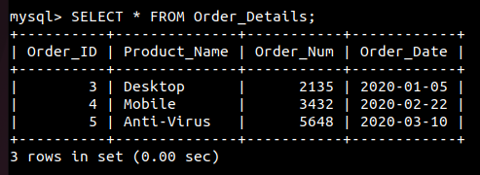

o) Commit the changes and enable autocommit.

>>COMMIT;

>>SET AUTOCOMMIT = 1;

